Texas Holdem Final Proposal

We, as a group, decide to continue modifying our game, Texas Holdem. Texas Holdem is a poker game that deals with a deck of 52 cards. At the beginning of the game, each player will have an initial amount of money, called stacks, for betting and will receive 2 cards, called holes. Depending on the stack amount, there will be a minimum amount of money that each player can bet or raise. During the first round of each game, there will be a player assigned as small blind, and the player left of them will be assigned as the big blind. After each game, the player that was the big blind will become the small blind and to the left of them will be assigned as the big blind. The small blind will always have to bet the minimum amount required to bet and the big blind will have to raise to twice the amount of what small blind has bet or higher. Then, during this round, all the other players can only fold (forfeit their cards), call (wager the same amount as the big blind), raise (wager more than the big blind or the previous player/players), or call all-in (wager your whole stack of money). If the previous player wagers, or wagers more than the previous players, the current player will only have limited actions to deploy. Once all the player has called to the highest bet then the next round (the flop) begins. When the flop starts, 3 cards will be distributed to the middle of the table faced up (community cards). These cards are used to determine the highest hand of cards for each player. During this round, the small blind will begin the round with 4 options; fold, bet, check, or call all-in. If the small blind folds or checks, then the next player has the same option as small blind. If small blind decides to bet, or call all-in, then the next players’ options will be limited to fold, call, raise, or call all-in. Once all the players have implemented their actions and/or everyone has called to the highest bet, the next round (the turn) begins. The turn has the same actions as the flop and so does the last round (the river). After the river, everyone’s cards are turned over (assuming there are 2 players or more left in the game), whoever has the highest hand, wins the entire pot. Then, the game resets, the players return all their cards to be shuffled and redistributed and the stack of each player is updated according to their actions from the previous game(s).

Texas Holdem Poker Hands:

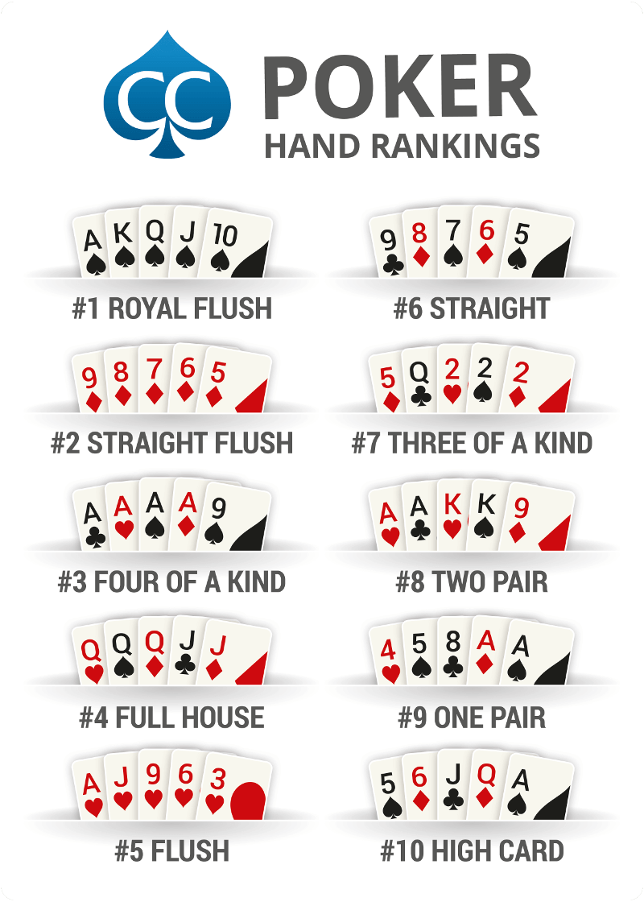

John Lowie

Brayden Schmaltz

Kyle Wai

Adam Hiles